Backpack across the Andes in the stunning Lakes District of Northern Patagonia with fellow Mountaineers in February-March of 2016!!

Most people have heard about the granite towers and lakes of southern Patagonia, but the peaks and lakes of the northern Patagonian Andes are a relatively undiscovered treasure for North American hikers and backpackers - a treasure often mentioned by local guides as their favorite place to backpack in all of Patagonia! And it’s summer in the southern hemisphere, so you can climb high in the mountains while the PNW is still dreary!

This Mountaineers Global Adventure consists of two linked outings - register for just the first segment, or for both.
Late Feb to early March 2020. BACKPACK ACROSS NAHUEL HUAPI NATIONAL PARK
Starting in Bariloche, Argentina, explore and backpack with a guide for 9 days in Argentina's oldest national park, along high ridges above glacial lakes to the flanks of massive Tronador volcano. Then transfer back to Bariloche on a ferry on huge Lago Nahuel Huapi. Carry your own overnight gear or hire a porter and carry only a daypack. Trip price ~$3000 including all ground and ferry transportation, lodging, meals and guides.

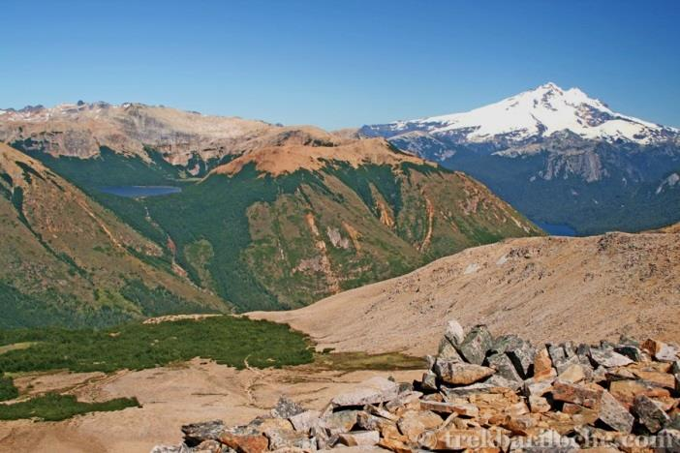

Early to mid March 2020. EXTENSION: EXPLORE THE INCREDIBLE “SEVEN LAKES” AREA, HOT SPRINGS AND VOLCANO LANIN. 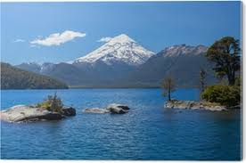
Starting from Bariloche after the Nahuel Huapi adventure, take 5-6 additional days to travel north around the famed “Seven Lakes Loop” and on to Lanin National Park, trekking up the slopes, around its lakes and stopping at the Lahuen hot springs along the way. Stay in hotels or possibly a few nights’ camping. Guided throughout. Trip price $1500-2000 estimate

For more information, contact Cheryl Talbert at cascadehiker@earthlink.net or at 253-229-4018.

