Trek through Ancient History on Turkey’s Aegean and Mediterranean Coasts
Mid April to early May, 2020

Overview: The Anatolian peninsula has been a crossroads of civilization for centuries, and the ancient Carian and Lycian civilizations along its southwestern and Mediterranean coasts are among the most ancient. Here mountains rise steeply from a rocky coast, with beautiful views out over the turquoise sea. The people who occupied these coasts from the Bronze age (1300BC) through the rise of the Byzantine empire were prosperous, democratic and independent with well-developed cultures and art shaped by Persian, Greek, Roman and Byzantine rule. Now, elaborate tombs and extensive ruins abound, scattered among the rocks, forests and pastures, including some of the world’s most famous excavated Greek sites and antiquities. During April to early May, wildflowers will be blooming in profusion and the weather will be mild, perfect for trekking!
Carian Way Itinerary (mid to late April 2020) Starting from the city of Izmir, an easy flight from Istanbul, we’ll first visit the ancient Greek sites of Ephesus, Selçuk and Aphrodisias, then transfer by van to the start of our trek on the shore of Bafa Lake. Over the next 7 days we will day-hike extraordinary sections of the Carian Way around Bafa Lake and on the Bozburun peninsula, ending in Marmaris.
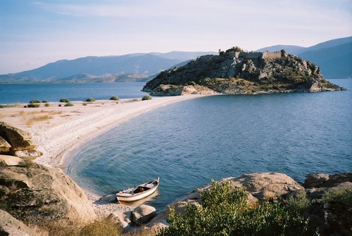

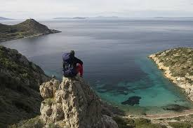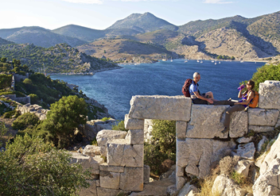

Lycian Way Itinerary (Late April to mid May 2020). The Lycian Way is a 310 mile network of ancient paths, mule and caravan trails and backcountry roads, connecting a number of villages, mountain hamlets, Lycian and Roman sites on its route along the Mediterranean. Along its length it ranges from sea level to the 7800-foot summit of Mt Olympos. Over 14 days we will hike the best 100 miles of the Lycian Way, starting in the west at Oludeniz, and ending in of Antalya to the east. The route ascends dramatic coastal ridges and bluffs and descends to the shore, including a half day cruise on the blue Mediterranean by yacht over the sunken city of Kekova.
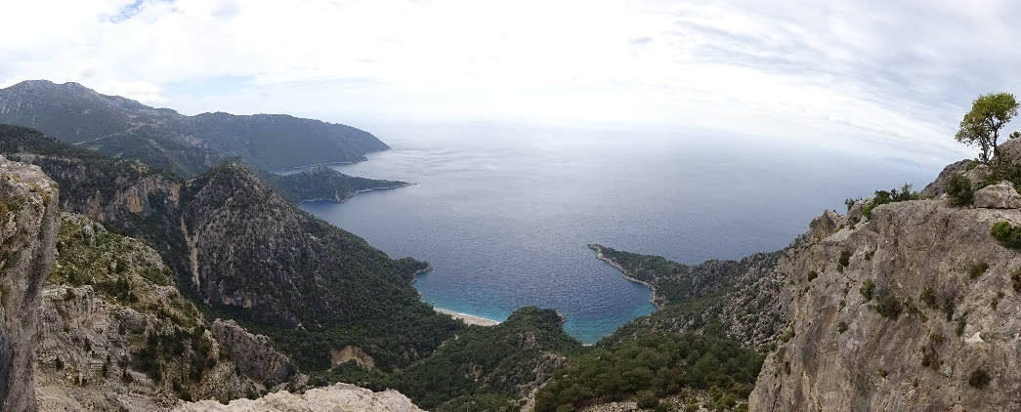
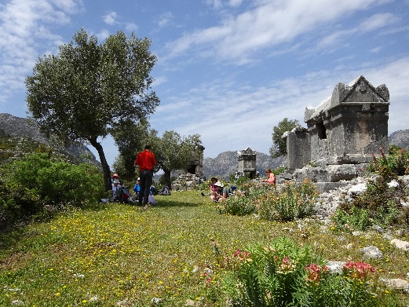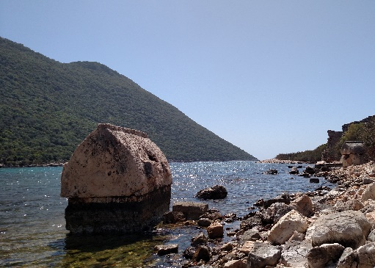
.

Trekking days will range from 6 to 11 miles with 250 to 3000’ daily gain. Our luggage will be transported and food prepared for us along the way, so we only need to carry a daypack. We’ll stay in nice small hotels and simple village houses, eat tasty local foods simply prepared, and enjoy the warm hospitality of the Turkish people. Along the route we’ll have time to relax by the sea, explore nearby ruins and views, bike around in a village along the crystal coast, take a gondola to the top of a high peak, and kayak along the scenic coastline.
Extension in Istanbul (before start of Carian Way). We’ll spend 3 full days staying in the Old City of Istanbul, touring the historic sites of its Greek, Roman, Byzantine and Ottoman periods with a local guide, sampling its cuisine and boating up the mighty Bosporus.
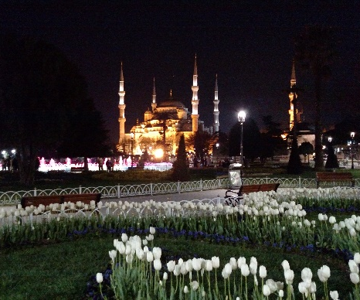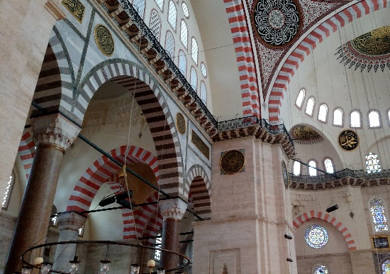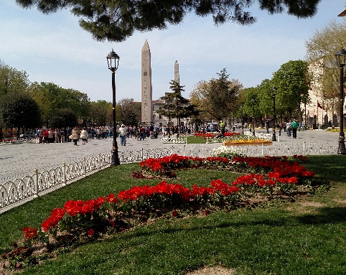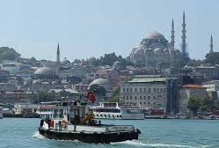
Extension on the island of Rhodes (between the Carian Way and Lycian Way treks). If sufficient interest, we’ll ferry an hour from the port of Marmaris (the terminus of our Carian Way trek) and spend 4 days hiking, kayaking and exploring the cultural riches of this largest of the Greek islands. It’s history dates back to the 16th Century BC and carries rich relics from ancient Greece and Rome, the Crusades and the Ottomans, as well as trails that climb high for dramatic views and drop to secluded beaches.
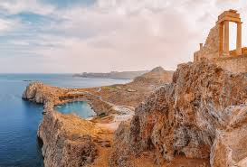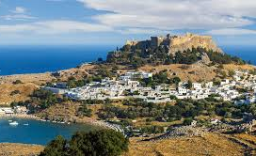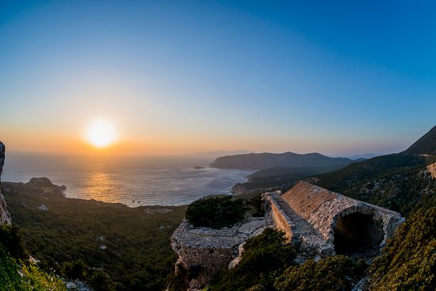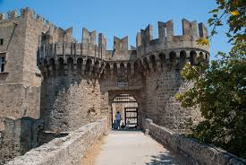
Participant Requirements: Participants need to be in excellent cardio-vascular condition with the endurance, balance and confidence to travel on steep rough trail for 10+ miles a day for several days in a row.
Price: ~$1500 for the Carian Way trek, ~$2300 for the Lycian Way trek, ~$500 for the Istanbul extension, and $650 for the Rhodes extension (final prices may vary based on final headcount and itinerary). Includes all lodging, ground transport and guides, luggage transport, and nearly all meals, plus Mountaineers admin fee and leader’s costs. Does not include international airfares (~ $1,300), hotels before and after the itinerary, some lunches, snacks and drinks in town, optional tours, or any personal items.

