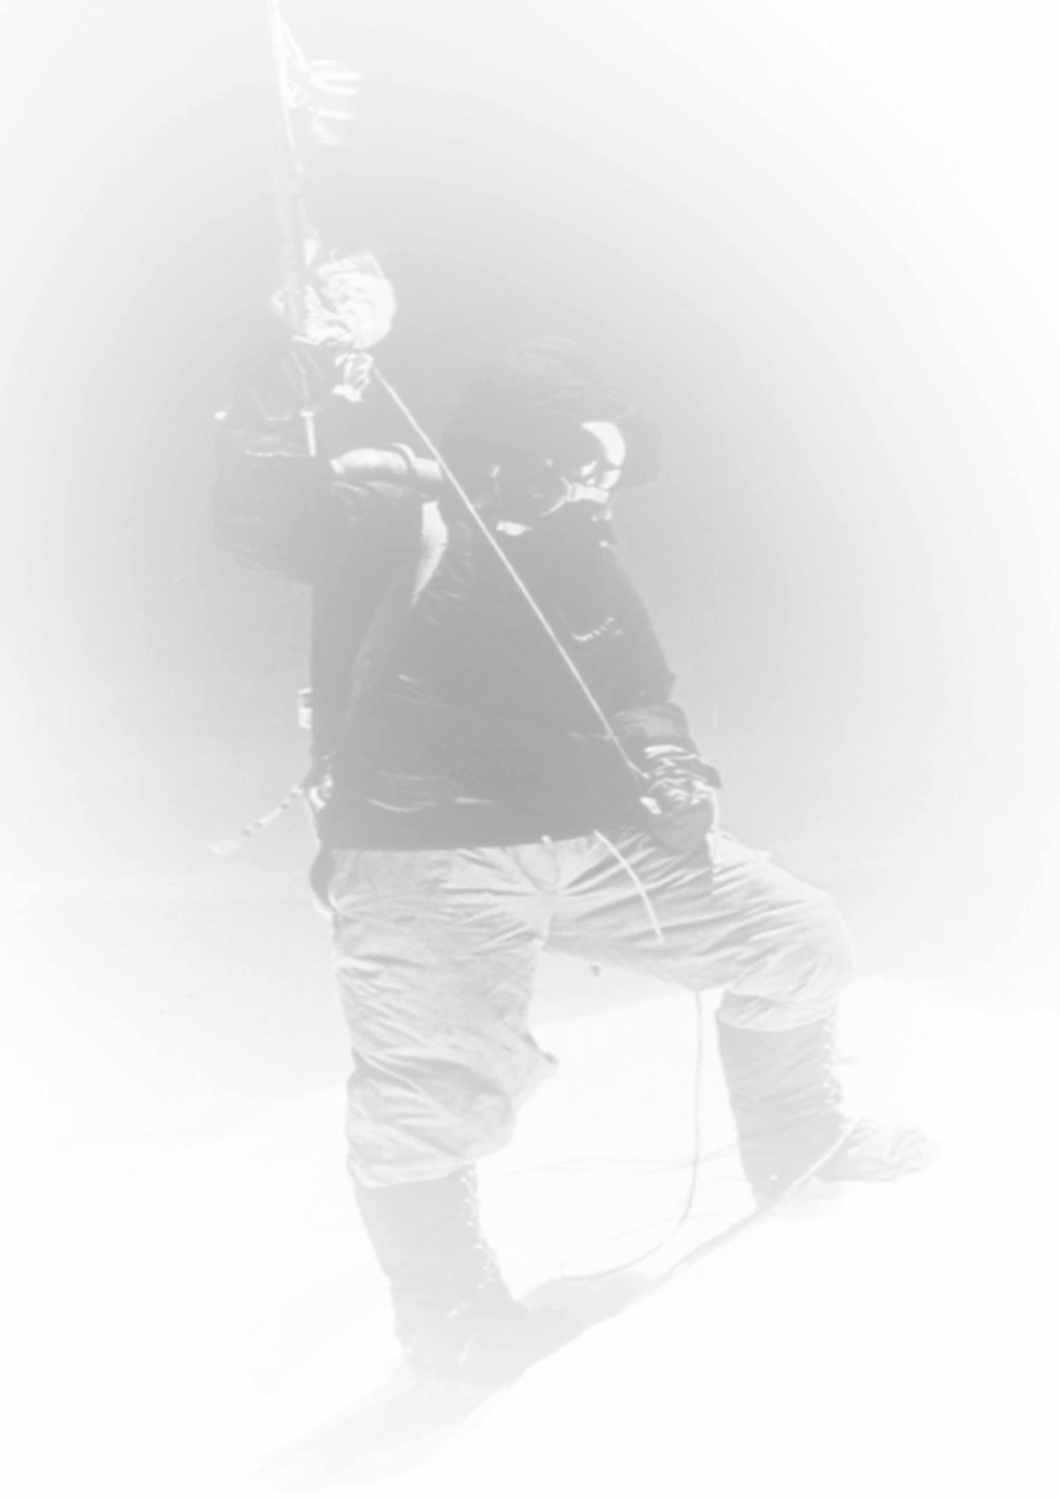
About the Speaker
Not only did Jamling Tenzing Norgay make it to the top of the world’s most forbidding mountain – described by the Sherpa people as “The Mother Goddess of the World” – but he also helped capture it all on film. As the Star of Director David Breashears Imax film Everest, Norgay helped to portray not only the physical challenges of the Mountain, but also the mental and spiritual challenges faced by the climbers.

Described as the “Titanic of Documentaries,” Everest has played to sold out audiences across the country, capturing for the first time on large format film the breathtaking view from Everest’s summit. Filmed during the same spring that nine people on Everest died in a sudden storm, it depicts the selflessness exhibited by Norgay and his companions in risking their own lives to save their fellow climbers.

While filming on the mountain, Jamling thought often about his father, trying to imagine what he had gone through in the early days. “ It was much harder then, “ Norgay said. “ There was no route; he and (Hillary) didn’t even know if the summit was achievable. Many had failed.

On his summit day, as the younger Norgay approached “The Balcony“ (at 27,000 feet Hillary ‘s and his father’s last camp), Norgay looked for remnants –but of course, there was nothing but snow and ice. “ I never felt so strong in my life. It was as if my father’s spirit was with me,” he says, describing his conditions as he inched closer to the top. “ Just when I thought I’d never get there, I saw Ed Viesturs coming down and he said, ‘Hey, it’s right there’”.

Norgay recalls feeling so happy that he cried. A Buddhist, he planted a lungta (prayer flag) and photos of the Dalai Lama and his late parents in the pristine summit snow. Then, just as his father had done 43 years earlier, he left a small toy of his daughter ‘s and struck “the pose” – the same dignified stance his father had assumed in 1953, which had etched an indelible image in the minds of the millions who had read about it afterward.

Norgay released his new book “Touching My Father’s Soul” in the spring of 2001 in San Francisco, and it has been released in 18 languages since then. His book has reached the 24 spot on the New York Times Best sellers list, and # 15 in Germany. It has been nominated for 3 awards in Canada, London and the U.S.

Today Norgay runs his adventure travel company “Tenzing Norgay Adventures” in Darjeeling, India and is often asked whether there are more big summits in his future. “I promised my wife that after Everest, I would never climb again,” says Norgay.” I will not break my word.

Introduction to Jamling Tenzing Norgay
In 1953, humankind reached a new pinnacle when Sir Edmund Hillary and Tenzing Norgay ascended to the summit of 29,035-foot Mount Everest. These two men faced the grueling hardships during this inaugural expedition, pushing the envelope for humanity without the aid of modern equipment and setting unprecedented standards for the climbing world. These pioneering adventurers explored the thresholds of physical limitations when they scaled the icy slopes of Everest, encountering some of the most severe weather conditions on Earth.
The saga, however, does not end here. Both the suffering and the triumph of these two men have inspired dozens of today's climbers to summit Mount Everest. Defying Mother Nature has resulted in many tragic incidents, but the tales of personal accomplishment and survival in the face of ultimate adversity reflect the intensity and drive that are deeply rooted in the human spirit.
Jamling Tenzing Norgay, the "Son of the Everest Pioneer," did not idle in the shadow of paternal legacies. He is a member of a living dynasty of climbers, with 11 of his relatives summiting Mount Everest. Jamling's spiritual journey has led him to an attachment to the Himalayan region and its jagged 8000-meter peaks. Because of his acclaimed mountaineering expertise, Jamling is a highly sought after guide who leads novices and experts alike into his hazardous domain, maintaining an ancient family profession in a modern era. Based upon his experience and reputation as a world renowned mountaineer, Jamling was also chosen as the Climbing leader of the International climbing team that created the awe-inspiring IMAX documentary film, 'Everest'. Jamling recently entered the literary world with Touching My Father's Soul, (an International Best Seller) a poignant reflection on his relationship with his father and his 1996 Everest ascent.
Physical accomplishments aside, Jamling has been instrumental in bringing much needed social services to many of the more remote Himalayan villages. His philanthropic contributions are as valued and honorable as his mountaineering endeavors. Please join me in welcoming Jamling Tenzing Norgay!

“TOUCHING MY FATHER’S SOUL”

An Odyssey to the Top of Everest

An illustrated presentation by Jamling Tenzing Norgay

“I climbed Everest so that my children wouldn’t have to.”
Ever since Jamling Tenzing Norgay’s father, Tenzing Norgay, spoke these words to his son, Jamling had been seized by a passion to follow in his father’s historic footsteps — to step onto Mount Everest’s icy skin and learn the lessons she has to teach. Destiny reserves the telling of some tales for certain people. In the illustrated presentation, Touching My Father’s Soul – An Odyssey to the Top of Everest,
Jamling brings to life a profound and compelling adventure, interweaving the lives of a family, a mountain and a people, and of climbers facing nearly insurmountable obstacles. It is a story of disaster, triumph, professionalism and the resilience of the human spirit. Clearly, it takes an unusual level of aspiration to simply decide to attempt Everest. To reach the summit and return safely to base camp demands extraordinary commitment and perseverance. On Everest, the stakes are high: Only one climber in seven who attempt it reaches the top. Of every five who do reach the summit,one dies trying.
The challenges are nearly overwhelming. Even veteran climbers face hypoxia (lack of oxygen — and the reduction in strength that accompanies it), altitude sickness, intestinal sickness, severe weight loss, homesickness, brutal weather conditions, recalcitrant porters, strained international group dynamic (11 teams crowded onto the mountain in 1996), and “objective dangers” such as being crushed by apartment-sized blocks of ice that litter the Khumbu Icefall, a glacier in motion.
Planning an Everest assault begins with piecing together a strategic puzzle: the pyramid of support whose foundation is balanced on the edge of an ominous, shifting glacier at 18,000 feet. Two tons of food, cooking fuel, supplemental oxygen, rope, hardware, tents — all must be carefully packed and dispatched in stages to the four high camps on the mountain. The leaders must exercise judgment, and in this case they were obliged to make sure that Sumiyo would return home safely, to have a future chance for the summit.
Within the “death zone” above 26,000 feet, a teammate or other climber in trouble puts all nearby climbers at risk. Judgment calls are difficult, and at this elevation they are downright arduous.

In Touching My Father’s Soul – An Odyssey to the Top of Everest, Jamling uses expedition slides to illustrate not only the organization and dynamics of the IMAX Filming team’s Everest climb, but he explores the natural and human events that led to the loss of 8 climbers in one storm and 12 climbers over the season. The IMAX team responded to the tragedy skillfully and compassionately, by shifting gears and immediately dedicating all of their oxygen and resources to the rescue. Two weeks later, following intense soul searching, consultation with Jamling’s family priest and study of weather conditions, they reached the top with the IMAX camera. One seldom sees such a level of organization and team effort: to film from the summit required that 11 people reach the top along with the camera, while 40 others delivered supplies and provided critical backup.

Throughout, Jamling interweaves the little known story of his father’s historic first ascent in1953, with Edmund Hillary, and shows how the mountain has changed
in the past half century — and how it hasn’t.

The Message

As Jamling found on Everest, in this captivating program we find more than personal triumph and family honor. We discover that climbing this mountain safely requires leadership, planning, confidence, commitment, apprenticeship, experience, humility -- all in a measured balance. For each of these attributes, Jamling provides examples of how they were used to further his team’s effort, how they contributed to their safety, success and response to the tragedy.

With the right combination of attributes and proper motivation, climbers are sometimes granted a chance to step onto Everest’s icy skin, and then retreat, taking with them important lessons about the human condition and what it takes to succeed. Indeed, the Sherpa people especially recognize that one can’t conquer Everest, and that respect and experience are one’s most essential companions. The objective is not the top of the mountain, for that would be like setting a goal of swimming to the middle of the ocean. Or, as team member Ed Viesturs put it, “Getting to the top is optional, but getting down is mandatory.”

Aspiration and ambition are essential, but the mountain cannot be climbed on hopes and dreams alone. In this program, we learn about what it really takes to succeed, and we learn some of the lessons that this dangerous mountain has to teach us.

It turns out that Jamling did have to climb Everest – in order to learn these lessons himself.

