# Coassemble Reports

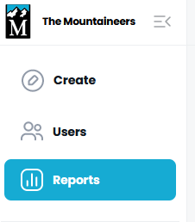

# Results

To use, filter for course and group.

Features:

* **Export to CSV**
* View modules completed and assignments accepted

Drawbacks:

* No user sort
* No drill down or visibility to assignments

# Course

To use, find and expand your course and select group to see users.

Features:

* Course progress summary for group
* **Sort** by user name
* Some assignments are viewable by clicking
* **Module shows completion date** as check against broken completion summary percentage at bottom and on reporting

Drawbacks:

* Export doesn’t work all the time
* Some assignments are NOT viewable by clicking

# Group

To use, click on group name.

Features:

* Group progress summary for courses
* Sort by user name
* Some assignments are viewable by clicking
* Module shows completion date as check against broken completion summary percentage at bottom and on reporting

Drawbacks:

* Some assignments are NOT viewable by clicking

# Learner

To use, find the learner

Features:

* Sort by user name
* Similar detail to other details by user

Drawbacks:

* Every learner in the system is included, so not useful for monitoring one group or one course