These are the corners in the Baring quad, with the UTM labels and their faint blue tick marks outlined in red. The faint blue ticks are what you connect up-and-down and left-to-right to draw the UTM grid. Note that some of the UTM labels are abbreviated, leaving out the last three zero digits (like saying five thousand).
So, on the left, you’d connect 613000m E on the top to 613, which is abbreviated, on the bottom. And, on the top, you’d connect 5303000m N on the left to 5303, which is abbreviated, on the right.
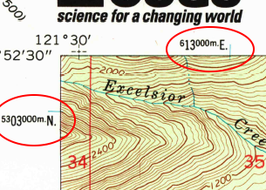 | 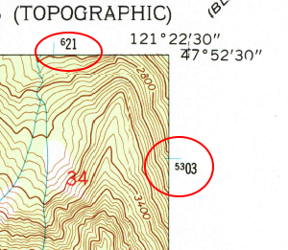
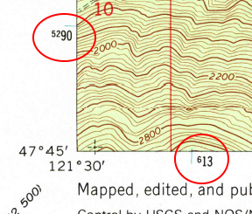 | 