Minutes – March 19th, 2015
Chair Timmy Williams called the meeting to order at 7:05 pm. Present were Williams, Peter Hendrickson, Mike Hansen (for Scramble & Safety), John Jecker, Alan Vogt, Anne Smart, Gordon Swartzman, Elvind Sleveland, Dave Shema, Steph Schiller (Climb Chair as of 1 April), Jimmy Jett-Klansic, Heidi Walker, Kay English and Eldon Ball.

Approved January 2015 Minutes –- Moved A Smart, H Walker. Passed.

Announcements –
- Meet the Mountaineers will next be 9/21/2015.
- New Climbing Chairperson Steph Schiller was introduced by Dave Shema who explained that chairs will now serve 6 months as chair elect, 12 months as chair and 6 months as immediate past chair.
- Friction Slabs are expected to be completed in September 2015. Contractor is Turnstone.
- A new financial staffer should soon start at the Program Center.
- The next Mountaineers Leadership Conference is planned for December 5.
- The Mountaineers have joined the Outdoor Alliance.

Old Business –
- Badges – Timmy appointed H Walker to review the current Badging Scheme, review reactions from the branches and prepare a recommendation to the Branch to move to the Managing Committee. Deadline for the recommendations is the next Seattle Branch Council meeting.
- Managing Committee has proposed an amendment to the Managing Committee charter to have the chair be a member of the Board of Directors appointed by the Board of Directors.
- The recent Website SuperUsers Survey caused some issues as it appeared that SurveyGizmo 7-day trial enrollment was required to enter the survey. Timmy will take the concern to staff.
- The three Hot Buttons which emerged from a recent survey by the chair were:
  - Communication between BOD, Staff and Branches (the volunteer corps)
  - Volunteer sense of being marginalized, left-out of decisions and implementation schemes
  - Finances
  - (Close fourth) Website with all respondents noting concerns. Williams noted that $200K per year is set aside over the next biennium for web development/management following the initial $350K development cost.
- Adjacent street safety concerns have not abated. Calls for lighting, a crosswalk and an open traffic gate (to redirect traffic) were made. They will be passed along to the building management committee.

New Business –
- Meet the Mountaineers this week was a bust with low enrollment, a pattern noted over the past two events. A staff apology around promotional activities was noted. One member wondered if staff time allocated to higher profile events left more routine operational activities under promoted. Chair will await remedial action from staff.

Committee Reports & Announcements

BoD – Patrick Mullaney no report

Safety Officer –Janine Burkhardt (M Hansen stand in) wishes reports to be more widely disseminated. Themes emerge in viewing reports from all branches. Venues suggested included Leader Lines, Climbing Highlights, Navigation Northwest...

Treasurer –John Jecker reported an unremarkable (but positive) financial position.
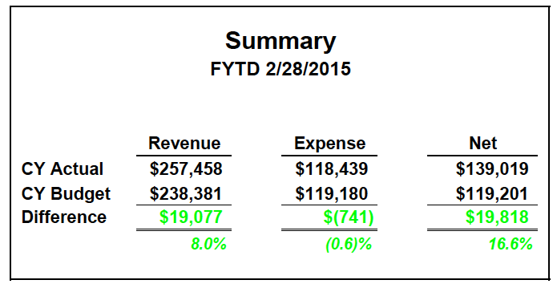

John noted the that capital donations and expenses for the friction project are not included but will track them down.
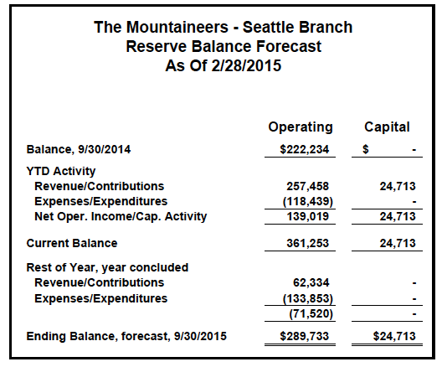
The Treasurer said that neither membership over time, nor current membership in the Branch (which appears to decline since about April 2014, is easily explained with the current data in the system.

Secretary – Peter Hendrickson reported nothing new from the Secretary’s virtual desk.

Alpine Scrambling –Steve Russell (M Hansen this meeting) reported 102 enrolled with 9 holdovers to the current year. Self-arrest practices appear problematic with high snow levels. Revenues are 1/3 behind current budget.

Backpacking – Mary Roman No report

Climbing – Dave Shema reported the third all-branch summit was just completed to manage competing indoor and forest service demands. Climb year 2016 is scheduled.

Folk Dance – Eivind Sleveland reminded the Secretary of his spelling and requested a fresh name tent. Attendance is good; finances are in the black and activities are soon to be reported as events (if Cindy Hoover or Suzanne Gerber can help).

Family Activities – Becca Polglase no report.

First Aid – Mary Panza no report.

Hiking – Heidi Walker reported 17 are enrolled in the Conditioning Hiking Series (CHS) and the regular class has 89 enrolled with a wait list. Leaders will be oriented this weekend. Basic Wilderness Skills is ready to launch.

Leadership – Mike Sweeney/Lawrence Landauer no report.

Midweek Hikes – Ed Lewin no report.

Naturalists – Gordie Swartzman (Kay English today) reported difficulty filling the course. Expect 60 to 80 but have only 18. Hoping for greater promotional activity.

Navigation – Peter Hendrickson reported that Basic Navigation Course actual field trip enrollments February and March have been Students: 66, 65 and 57 with Instructors 31, 21, 22 and cancellations 61, 68 and 52. No shows over the weekend approached 10 each day. Concerns about student readiness for supreme wet/cold. Wait list over 10 with 90 enrolled for 11 April. A $7 Chinese compass is on the market through Amazon. Ordering and evaluating.
Peter made rounds of corresponding Branch committees to seek input about any revisions to the Basic Course and (as ever) solicit instructors. Seeking tales of “off trail” experiences for Navigation Northwest. Next issue will be late March. Committee will host Bob and Mike Burns next week to celebrate 3rd edition of Wilderness Navigation. A YouTube navigation skills, setting declination, is now posted on YouTube. The committee is working with Mountaineers Books to produce a donor funded, BOD authorized, pilot Basic Navigation online, eLearning course. Other branches have been invited to contribute documents and join in the project. Copyright issues were raised.

Photography – Anne Smart reported cancelling a recent basic class due to low enrollment (12) compared to 80 to 100 three to four years ago. Concern about promotional strategies including FBook. The April class now has 17/40 enrolled. Concerned that a recent Club photo contest and BeWild speaker (photographer) did not involve the committee. Noted that club photographers may be reluctant to lose copyright by posting on FBook.

Retired Rovers –Storm Yanicks no report.

Sailing – Alan Vogt reported filling 53 of 60 sailing slots, many in response to a recent, blustery sail. Appreciation was noted for the recent, glorious photo spread and story in Mountaineering.

Paddle Sports – George Swapp no report.

Singles Activities – Eldon Ball reported needing more committee and activities. He also found three snow patches last week but was not seeking a badge for same.

Skiing – Cindy Hoover no report.

Snowshoeing – Jimmy Jett reported strong enrollment (90 + 30 waitlist) but managing cancellations has been challenging. Slots are not taken but they do not open promptly with students given up to 5 days to accept or reject an newly opened position. Grace Crk provides adequate snow for activities. One trip was cancelled due to blow downs on US Hwy2.Few Back Country enrollees and snow camping has been impacted with the low snowpack. Contemplating leadership seminar across branches but would need same before the December Leadership Conference.

UTHR’s – Jack Nichols no report.

Youth Outreach – Becca Polglase no report.

Staff—Suzanne Gerber no report in person but items noted in Announcements.

Full Committee discussed:
- Desire to have an opt-in by activity type to receive email notifications of new postings.

Good of the Order

The meeting was adjourned at 8:31 p.m. (Motion A Smart, J Jecker). Next meeting is My 21, 2015.

The Seattle Branch meeting occurs on the 3rd Thursday of every odd month, 7pm. For 2015 –

May 21 – Jul 16 – Sep 17 – Nov 19

(Rev 20Mar2015/ph)

