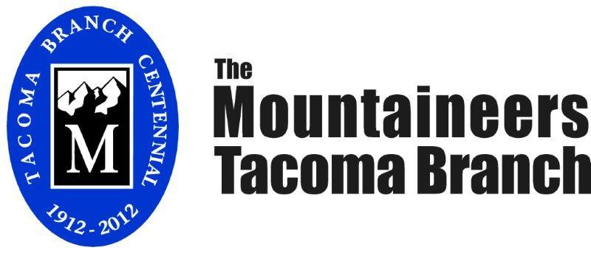

**Specifications**

**The Mountaineers Tacoma Program Center**

2302 North 30th Street, Tacoma, WA 98403

**Great Hall (First Floor)** 52’ x 22’ (1150 SF) - Suitable for larger gatherings with adjoining caterer food staging area with modest kitchen facilities; seats 120 people theater style, 64 to 80 for banquet seating; up to 170 for a standing reception; 12 banquet tables (8’ x 30”) & 120 chairs available.

**Class Room (Second Floor)** 35’ x 25’ (875 SF) - Suitable for classroom training; seats about 30 at tables or 42 theater style plus 9’ x 18’ table/lectern area; coffee & hot water access; 12 training tables (70” x 20”) and 40 chairs available.

**Board Room (Second Floor)** 18’ x 18’ (364 SF) - Suitable for meeting room seating 10 around table (plus 6-8 in observer chairs), plus chart board, etc.; coffee & hot water access.

**General**

* Center is served by modest kitchen facilities, suitable as a caterer staging area
* Restrooms on first and second floors
* Pull-down projection screens, electrical outlets, phone jacks in all 3 rooms
* Wi-Fi enabled entire building suitable for teleconferencing
* Large front windows with partial view of Commencement Bay from both floors; room darkening shades for projection displays
* Private fenced backyard
* Free parking is on side streets and in a city-owned parking lot on Carr Street
* Catering, bartending, security, photo & film, audio & video recording available through separate contractors
* Available equipment includes speakers, projector and screen, speaker lectern, and microphones
* Access to climbing walls & climbing safety personnel by special arrangement

For Further Information contact the office at 253 566-6965 or info@tacomamountaineers.org